LCC Pico Node User Guide
  - Version 3.0
This version utilizes the MCP2815 and MCP2562 discrete hardware components (chips) for the LCC interface.
The intent of this node is to control 16 pins on two 10 pin IDC connectors for a model railroad layout. It exposes 16 GP pins through two 10P IDC connectors, plus an additional 5-pin analog header (I/O-3), for general-purpose I/O. While it will work with either the Pico or Pico2, the latter is recommended due to enhanced capabilities.
There are no resistors on the Reset, Blue, and Gold button lines other than for the Blue and Gold LEDs.
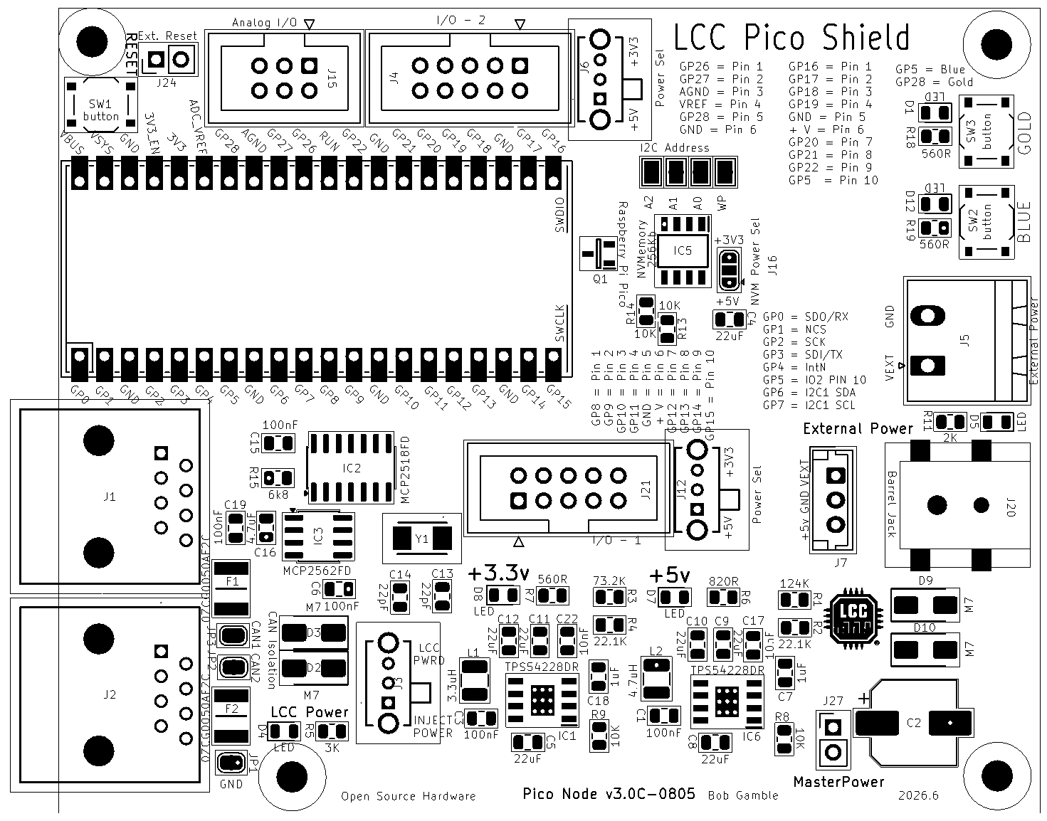
The node may be powered from the barrel jack or the LCC port. The barrel jack power should be at least seven (8) volts to power the microcontroller or fifteen (15) volts [or your preferred LCC voltage] if using the node to inject power to LCC. Amperage should be sufficient to drive any external devices plus about half an amp for the node plus another 1.5 amps if injecting power to LCC. There are six power LEDs. Five should be lit to indicate that the node is properly powered, six if barrel jack powered.
Node power configuration is accomplished with five jumpers located behind the LCC ports.

J1 Pwr (JP2) and J2 Pwr (JP3) jumpers allow power isolation of one or both LCC ports. Generally, both jumpers would be bridged. If power injection or utilization was only desired in one direction, then the opposing jumper would be opened to isolate that leg. The isolated leg should be powered downstream as opening the jumper will cut off any power from the node.

LCC Grnd jumper should be bridged. If cut, ground will be isolated from the CAN bus which may impact communication.
Switch position for LCC Pwrd should be selected if the node is to be powered from the LCC Port.
Inject Power should be selected if the node is intended to inject power to one or both of the LCC ports. 15 volts of at least 1.5 amps should be applied externally in order to inject power.

Master Power jumper should be bridged to power the node. A normally closed button may be plugged in here as a means to do a hardware reset should there be a need to hard cycle the power.


J24 jumper may be attached to a normally open button to function as a Reset as it is in parallel to the on board Reset button.


The power applied to the middle pins of the IDC connector may be selected by the power selection switch. Pin assignments are noted on the PCB.
The power applied to the middle pins of the IDC connector may be selected by the power selection switch and the solder jumper. Pin assignments are noted on the PCB.


NVM Storage

I2C nonvolatile memory is used to reduce strain on the Pico flash. External NVM is soldered down to the IC5 footprint. The I2C Address jumpers may be used to select non-default addresses or implement write protection. Otherwise, these would be functions of the module plugged into the I2C header.
Parts compatible with the following should work for soldering to the footprint on the board.
- BR24G256F-3AGTE2 I2C BUS(2-Wre) 256K or other sizes with equivalent pinouts
- MB85RC256VPF-G-BCERE1 256kbit FRAM with I2C

I2C address may be selected by the left three jumpers.
Either 3.3V or 5V may be selected by this solder jumper. The selection will apply to the soldered NVM module, I2C1, and FRAM Breakout header.
I2C nonvolatile memory may be populated if desired to reduce strain on the Pico flash. Parts compatible with these should work.
BR24G256F-3AGTE2 I2C BUS(2-Wre) 256K
MB85RC256VPF-G-BCERE1 256kbit FRAM with I2C

Board Pin Assignments
Pin | GP | Alt 1 | Alt 2 | v3.0 Node
1 | gp0 | SPI0 RX | I2C0 SDA | ACAN_RX_PIN
2 | gp1 | SPI0 CSN | I2C0 SCL | ACAN_CS_PIN
3 | GND
4 | gp2 | SPI0 SCK | I2C1 SDA | ACAN_CSK_PIN
5 | gp3 | SPI0 TX | I2C1 SCL | ACAN_TX_PIN
6 | gp4 | SPI0 RX | I2C0 SDA | ACAN_INT_PIN
7 | gp5 | SPI0 CSn | I2C0 SCL | I/O-2: Pin 10 & Blue Button
8 | GND
9 | gp6 | SPI0 SCK | I2C1 SDA | I2C1 SDA
10 | gp7 | SPI0 TX | I2C1 SCL | I2C1 SCL
11 | gp8 | SPI1 RX | I2C0 SDA | I/O-1: Pin 1
12 | gp9 | SPI1 CSn | I2C0 SCL | I/O-1: Pin 2
13 | GND
14 | gp10 | SPI1 SCK | I2C1 SDA | I/O-1: Pin 3
15 | gp11 | SPI1 TX | I2C1 SCL | I/O-1: Pin 4
16 | gp12 | SPI1 RX | I2C0 SDA | I/O-1: Pin 7
17 | gp13 | SPI1 CSn | I2C0 SCL | I/O-1: Pin 8
18 | GND
19 | gp14 | SPI1 SCK | I2C1 SDA | I/O-1: Pin 9
20 | gp15 | SPI1 TX | I2C1 SCL | I/O-1: Pin 10
21 | gp16 | SPI0 RX | I2C0 SDA | I/O-2: Pin 1
22 | gp17 | SPI0 CSn | I2C0 SCL | I/O-2: Pin 2
23 | GND
24 | gp18 | SPI0 SCK | I2C1 SDA | I/O-2: Pin 3
25 | gp19 | SPI0 TX | I2C1 SCL | I/O-2: Pin 4
26 | gp20 |  | I2C0 SDA | I/O-2: Pin 7
27 | gp21 |  | I2C0 SCL | I/O-2: Pin 8
28 | GND
29 | gp22 |  |  | I/O-2: Pin 9
30 | RUN |  |  | Reset Button / header
31 | gp26 | ADC0 | I2C1 SDA | I/O-3: Pin 1
32 | gp27 | ADC1 | I2C1 SCL | I/O-3: Pin 2
33 | GND | A GND |  | I/O-3: Pin 3 (AGND)
34 | gp28 | ADC2 |  | I/O-3: Pin 5 & Gold Button
35 |  | ADC_VREF |  | I/O-3: Pin 4 (VREF)
36 | 3v3_OUT
37 | 3V3_EN
38 | GND
39 | VSYS
40 | VBUS
 | GND |  |  | I/O-1: Pin 5
 | Vselect1 |  |  | I/O-1: Pin 6
 | GND |  |  | I/O-2: Pin 5
 | Vselect2 |  |  | I/O-2: Pin 6
Note: I/O-2 Pin 10 (gp5) and I/O-3 Pin 5 (gp28) double as the Blue and Gold buttons. A breakout that uses either of those pins makes the corresponding button unavailable.

Bill of Materials
Qty | Value | Reference | Mfr. # | Description
6 | 0.1uF, 100nF | C1,C3,C6,C15,C19,C20 | C1206C104K3RAC7411 | Multilayer Ceramic Capacitors MLCC - SMD/SMT 25V 0.1uF X7R 1206 10%
1 | 470uF | C2 | REF1016471M035K | Aluminum Electrolytic Capacitors - Radial Leaded Radial Leaded Aluminum Electrolytic Capacitor
7 | 22uF | C4,C5,C8,C9,C10,C11,C12 | CL31A226MOCLNNC | Multilayer Ceramic Capacitors MLCC - SMD/SMT 22uF+/-20% 16V X5R 3 1206
1 | 1uF | C7 | CL31B105KAHNFNE | Multilayer Ceramic Capacitors MLCC - SMD/SMT 1uF+/-10% 25V X7R 32 1206
2 | 22pF | C13,C14 | C1206C220J3HACTU | Multilayer Ceramic Capacitors MLCC - SMD/SMT 25V 22pF X8R 1206 5%
1 | 4.7uF | C16 | CL31B475KOHNFNE | Multilayer Ceramic Capacitors MLCC - SMD/SMT 4.7uF+/-10% 16V X7R 1206
1 | 470nF | C21
6 | LED | D1,D4,D5,D7,D8,D12 | 156120VS75000 | Single Color LEDs WL-SMRW SMD RvMt Mon Wtrclr Rect 1206BtGn
4 | M7 | D2,D3,D9,D10 | M7 | Rectifiers Diode, SMA, 1000V, 1A
2 | PwrG | D6,D11 | 156120VS75000 | Single Color LEDs WL-SMRW SMD RvMt Mon Wtrclr Rect 1206BtGn
2 | 0ZCG0035AF2C | F1,F2 | 0ZCG0035AF2C | Resettable Fuses - PPTC
1 | TPS54294PWPR | IC1 | TPS54294PWPR | Switching Voltage Regulators 4.5-18Vin Dual 2A Ou t Sync SD Cnvrtr A A 595-TPS54294PWP
1 | MCP2518FDT-E_SL | IC2 | MCP2518FDT-E/SL | CAN Interface IC Stand-alone Low Power CAN FD Controller w/SPI Interface Grade1
1 | MCP2562FDT-E/SN | IC3 | MCP2562FDT-E/SN | CAN Interface IC CAN Flexible Data Rate Transceiver
1 | TPS3840DxNBR | IC4
1 | MB85RCxxxV | IC5 | BR24G512F-3AGTE2 | EEPROM I2C BUS(2-Wre) 512K SOP8 EEPROM
2 | RJ45 | J1,J2 | MTJ-880X1 | Modular Connectors / Ethernet Connectors 8P8C TYPE 0 GLD FLSH BLK
1 | SRP3212A-2R2M | L1 | SRP3212A-2R2M | Power Inductors - SMD Ind,3.2x2.5x1mm,2.2uH+/-20%,4A, shd AEC-Q200
1 | SRP3212A-3R3M | L2 | SRP3212A-3R3M | Power Inductors - SMD Ind,3.2x2.5x1mm,3.3uH+/-20%,3.1A, shd AEC-Q200
1 | DMG2305UX-7 | Q1 | DMG2305UX-7 | MOSFETs P-Ch ENH FET -20V 52mOh -5A
1 | 124K | R1 | ERA-8AEB1243V | Thin Film Resistors - SMD 1206 124Kohm 25ppm 0.1% AEC-Q200
2 | 22.1K | R2,R4 | ERA-8AEB2212V | Thin Film Resistors - SMD 1206 22.1Kohm 25ppm 0.1% AEC-Q200
1 | 73.2K | R3 | ERA-8AEB7322V | Thin Film Resistors - SMD 1206 73.2Kohm 25ppm 0.1% AEC-Q200
3 | 3K | R5,R10,R12
1 | 820R | R6 | RT1206FRE07820RL | Thin Film Resistors - SMD 1/4W 820 ohm 1% 50ppm
3 | 560R | R7,R18,R19 | RT1206FRE07560RL | Thin Film Resistors - SMD 560 OHM 1% 50PPM 1/4W
4 | 10K | R8,R9,R13,R14
1 | 2K | R11 | RT1206FRE072KL | Thin Film Resistors - SMD 1/4W 2K ohm 1% 50ppm
1 | 6k8 | R15 | RT1206DRD076K8L | Thin Film Resistors - SMD 6.8 kOhms 250 mW 0.5 % 1206
1 | 560K | R16
1 | 100K | R17
1 | Raspberry Pi Pico | RPiPico1
1 | Pico Reset | SW1 | TS11-674-43-BK-160-RA-D | Tactile Switches 6 x 7.4 mm 4.3 mm 160 gf Black Right Angle Through Hole SPST
1 | Blue Button | SW2 | TS11-674-43-BK-160-RA-D | Tactile Switches 6 x 7.4 mm 4.3 mm 160 gf Black Right Angle Through Hole SPST
1 | Gold Button | SW3 | TS11-674-43-BK-160-RA-D | Tactile Switches 6 x 7.4 mm 4.3 mm 160 gf Black Right Angle Through Hole SPST
1 | ABM-40MHZ | Y1 | ABM3-40.000MHZ-B2-T | Crystals Xtal 5032 2-SMD 40MHz Tol +/-20ppm Stab +/-50ppm -20C - 70C 18pF 25 Ohms

Connections:
J3 | Select power from LCC or Inject Power to LCC
J4, J21 | 10 pin IDC connector I/O
J5,J7 | I2C Header
J6,J8,J12 | 3.3/5 Volt Power Selection
J9 | Fram Breakout header
J14,J17 | Pico Pinout Conn_01x20
J16 | FRAM Power Select
J18 | 5 volt power out
J19 | 3.3 volt power out
J20 | Barrel Jack power input
J24 | External Reset header
J27 | MasterPower bridge header
JP1 | J2 LCC Power enable
JP3 | J1 LCC Power enable
JP4 | LCC Ground enable
JP6-9 | NVM Address & WP

Software

Example Node Applications
- https://github.com/bocabob/LCC_RPiPico_Turntable
- https://github.com/bocabob/LCC_RPiPico_Roundhouse
- https://github.com/bocabob/LCC_RPiPico_PixelLights
- https://github.com/bocabob/LCC_RPiPico_Clock_Lights

Architectural Standard
Cross-project firmware conventions (board versioning, breakout pin assignments, configuration memory, naming) for all node applications above are documented in: https://github.com/bocabob/LCC_RPiPico_Common

Board Support
Use the RP2040 board library by Earle Philhower: https://arduino-pico.readthedocs.io/en/latest/install.html

LCC Support
- https://github.com/openlcb/OpenLCB_Single_Thread
- https://github.com/JimKueneman/OpenLcbCLib

CAN Hardware
- ACAN2517 Arduino library

External Storage
- I2C_EEPROM Arduino library by Rob Tillaart
- FRAM_I2C Arduino library by Rob Tillaart

NeoPixel
- NeoPixelBus by Makuna (preferred)
- NeoPixelConnect by Alan Yorinks

Other Preferred Libraries

Display
- TFT_eSPI_RA8876.h — display library (modified): https://github.com/bocabob/TFT_eSPI_RA8876
- RA8876_RP2040.h — display library (modified): https://github.com/bocabob/RA8876_RP2040
- my_bb_captouch.h — capacitive touch driver (modified): https://github.com/bocabob/my_bb_captouch

Servos
- ServoEasing.hpp — for slow servo action, including bounces
- PCA9685_servo_driver.h
- PCA9685_servo.h

Stepper Motor
- AccelStepper.h by Mike McCauley (modified)

